MGMT 489 Strategic Management

Verizon was formed back in 1998 this resulted by the largest mergers in the U.S. business history. It was between Bell Atlantic based in New York and GTE where they both evolved and achieved great success. GTE was valued for more than $52 million joining Bell Atlantic to serve thirteen states with advance data communications capabilities and long distance expertise. Their goal was to provide a respected telecommunication company with a data services nationwide as part of their package and to provide long distance. After following reviews and approvals the merge closed two years later.
At the same time this was happening Bell Atlantic announced in 1999 their agreement with London-based Vodafone Airtouch Plc (now known as Vodafone Group Plc), designated to have a single brand and common digital technology and to be constituted of the Bell Atlantics and Vodafone’s US wireless assets. After six months they obtained a regulatory approval and in April 2000 Verizon brand was launched creating the nation’s largest wireless company. Verizon began trading on the New York Stock Exchange (NYSE) on Monday July 3rd, 2000 under the VZ symbol. As of March 10, 2010 Verizon also began trading on the National Association of Securities Dealers Automated Quotations (NASDAQ) exchange with the same symbol.
Today Verizon’s president and CEO is Daniel S. Mead. Verizon runs the nation’s most reliable wireless network and leader in the 4G LTE. Verizon Wireless was the first national wireless provider of 4G LTE in the US. Verizon strives to provide the most advanced wireless technology available.
Verizon is a leader in delivering wireless communication to innovate business, government, mass market and whole sale customers. This company is based on shifting their products to a reliable and faster service and to provide a full service communication network that brings customers high speed.
Verizon has accomplished plenty over the years, this year for innovation Chief Executive Magazine named Verizon Top Company for Leaders 2013 earning #5 out of 40 best companies (Jan. 10, 2013), Ponemon Institute Survey ranked Verizon 11th among all U.S. companies Best-in-Class for privacy (Jan. 28, 2013), J.D. Power and Associates ranked highest among national wireless companies in Wireless Network Quality Performance Study (March 7, 2013), Fortune magazine ranked Verizon #1 in World’s Most Admired Companies (March 18, 2013) and Top 100 Technology Innovators (Sept. 30, 2013). In customer service Verizon was awarded Significant Improvements in Customer Service with 73 percent surveying “Very Satisfied” (Feb. 6,2013), J.D. Power and Associated for the fourth straight time ranked Wireless Customer Care Study (Feb. 7, 2013) and Training Magazine ranked Verizon #1 for Best in Employee Training (Feb 19, 2013).
The workplace excellence Verizon was ranked in the list for National Association of Female Executives (Feb. 5, 2013), Military Times awarded Verizon Best for Veterans (April 9, 2013), Civilianjobs.com for Most Valuable Employer for Military (May 2013), IDG’s Computerworld awarded them for the 11th consecutive year for Best Place to Work in Information Technology (June 17, 2013), Working Mother for the 12th consecutive year awarded Verizon for Working Mother 100 Best Companies (Sept. 23, 2013) and G.I. Jobs.com ranked Verizon #3 out of Top 100 Military Friendly Employer (Nov. 8, 2013).
Verizon diversity awards for this year are DiversityBusiness.com ranked Verizon #7 for Top Organization for Multicultural Business Opportunity (Jan. 15, 2013), Careers & the disabled Magazine named Verizon Top 50 Employer’s Readers Choice (Jan. 2013), Diversity Inc. recognized Verizon a Top Company for Diversity (April 24, 2013), Working Mother for 8 consecutive years Verizon was ranked Best for Multicultural Women (May 14, 2013), Diversity MBA Magazine named Verizon #1 company for Diverse Managers (May 23, 2013) and LATINA Style Magazine for the 11th consecutive year named Verizon Among Best for Latinas (Aug. 6, 2013).
Verizon vision statement is to be dedicated to their wireless business and to improve services to their customers as wireless technology changes. Their plan is to execute greater exposure by expanding, innovative marketing, and customer referrals. Verizon will continue its success by going above and beyond customers’ expectations while meeting their wireless needs. Verizon plans to continue to grow in their wireless market while covering and sustaining profitability.
Verizon mission statement is to offer a range of rate plans as well as cellular equipment to customers in Virginia and customers nationwide. Their goal is to keep the highest professional performance in this industry to secure business. They will perform to their best to provide customers the best quality service. Employees will understand their personal commitments to promote their net worth. Commitment to use the highest ethical standards in every decision made as well as to maintain the highest standards to always guarantee quality and reliability by Verizon Wireless.
Verizon Wireless has worked out because of their customer’s image of them of a high quality communications services. They provide excellent customer experiences through their products and their actions. Verizon believes that their customers pay money for them to provide outstanding quality and reliability services. The focus is the outward on their customers by listening, anticipating, and responding to their needs making it easy for them to do business. Having the highest ethical standard is about knowing your products and being able to explain it thoroughly to your customers. Verizon focuses on their customers being able to rely on them with a sense of urgency and having a great execution while doing so. Teamwork is about diversity and to provide customers with a better faster customer service. Verizon maintains a good team in staff by trusting one another by communication being the main key to respect. As a team to come up with one solution everyone agrees to support no matter how high or low their position maybe. Integrity is the core of Verizon besides being who they are integrity builds strong relationships with their customers to provide quality service. Verizon commits itself to do the right thing weather it would be with their customers, suppliers, owners or competitors. They like to see their competitors as challenges to develop new ideas like incorporation their success with their community. Verizon tries to keep the bureaucracy out of their business by maintaining it small and keep it active compared to other companies their size. Verizon faces difficult challenges every day and have to make decisions very sudden if necessary. Verizon has worked hard to build a strong foundations to help their corporate values be the face of their business by working twenty four hours to provide great quality for their customers.
Verizon keeps advancing its global optical network by coming up with new ideas more advance while technology changes. Having expanded their industries to health care, retail and financial services. We are focusing our strategy into diverse workforce where skills vary to answer customers challenging questions. Different cultures will bring enrichment, new thinking, and innovation. Giving us the competitive advantage that all leaders need to succeed.
Diversity and inclusion is part of who Verizon is by employees respecting each other and creating a culture of inclusion through our Employee Code Conduct. As well as through supplier relationships economic development, marketing and philanthropy. Diversity and inclusion starts at the very top of our company. Executives are held responsible for bringing diversity and inclusion by doing so performances are outstanding. Our employee performance reflects our customer service. In order to perform at our best we find out from our employees if they feel respected and valued in our company. Our employee’s talents are put to use in a variety of circumstances. We do this by using our employee’s to suit your needs, we hire men and women from different backgrounds, race, national origin, sexual orientation and generation. Forming strategic alliances with other groups such as advocacy groups and chambers of commerce. We encourage primary suppliers to be diverse.
Verizon Wireless 4G LTE network continues to lead the industry’s largest in the United States. At speeds up to 10 times faster than the 3G by offering high quality services and products. With 4G LTE customers can stream, share videos, real game time, multiple surfs, downloading, movies and photos with high speed and definition. Verizon has the nation’s largest and most reliable 4G LTE network, expanding their coverage to 303 million people, 500 markets to more than 97 percent of the U.S. population. The LTE in Rural America partners are helping expanding coverage to rural areas across America. Verizon believes in a secure network what they do is traffic pattern without interrupting normal valid traffic and protect customers from harmful sources.
Verizon as known is one of the leading providers of wireless communications in the U.S. as well as operating one of the most extensive IP network in the world giving it a high competitive advantage. Internal strengths are their market position, strong business, and ultra-fast FiOS internet connection. We have a vision of integration communication to our customer’s solutions at the place where they are and at any time they needed. Verizon is top fifty U.S. companies becoming the second ranker with a well-established Fiber DSL plant. Total sales held by the company as November 2013 is $119.53 billion. Covering all major cities of Europe and America providing our customers with a high speed uninterrupted network. Verizon is leading the way for competitors for $50.22. We have well experienced and qualified employees in different departments. Employees are being recognized for their performances and bonuses are being handed out.
Verizon internal strengths are to have strong market positions, strong business, and ultra-fast FiOS internet connections. Verizon is the known as one of the largest providers of wireless and broadband, so having a strong market positions are crucial. Verizon’s company has four business segments that generates more than $71 billion in revenue. With new technology and software updates, Verizon came up with the Ultra-fast FiOS Internet Connection, which operated from a fiber optic communication network. Verizon FiOS released the newest version called the FiOS Quantum which has a faster download speed.
Verizon’s internal weakness is customer service which we are working to improve. We believe our customer services is top notch but it can be a nuisance to call and deal with their call centers. Verizon believes that not all customer service representatives are given accurate information. Revenue has not incredibly increased, yet again the company has been in debt for a long term. Verizon is lacking international market but our strategic goal is to be diverse in employing to meet customers’ needs in different areas of expertise.
Verizon’s external opportunities are increasing demands for wireless broadband applications, expansions of audio-conferencing access and focusing on international expansion. With Verizon growing in technology we have a lot of customers with increasing demands of wireless broadband in the nation and to have an expansion in their audio conferencing. Verizon has big advantages to improve their technology and to expand globally with their services. By Verizon connecting America and Europe together with their currency is an advantage to the company. High speed internet is still being worked on to keep pace with other telecommunication companies as well as technology changes.
Verizon external threats are saturation in the wireless market, technology change, regulatory framework, and intense competition. Verizon believes that the sales of wireless contracts is the most profitable segment of the business. Verizon thinks that the saturation of the wireless market is going to come to a halt because of many different providers and so many devices are being created in the nation. One of our policies is the regulation imposed on Verizon to lease access lines to its competitors at quite low rates so that the access lines can be suitable for all of the providers that are leasing it. With many providers in the Nation, Verizon Communications and AT&T Inc. dominate the market for wireless data as a duopoly with more than two-thirds of all U.S. subscribers and the most Industry’s profit. Sprint, Nextel Corp., T-Mobile, USA Inc. and Metro Communications Inc. networks being as huge as they are now need to be kept up and maintained by regularly handling with a sense of urgency. There is still a tough competition out there brand recognition is still a main issue. Customer’s records are still not completely safe due to huge increase network day by day. Verizon is trying to run an excellent and experienced employees to meet customer’s needs, but this requires a heavy cost to be paid.
Verizon provides value of chain analysis because it is the fundamental elements of Chain Analysis. This type of method is critical to all business models. The basic breakdown is the one shown below.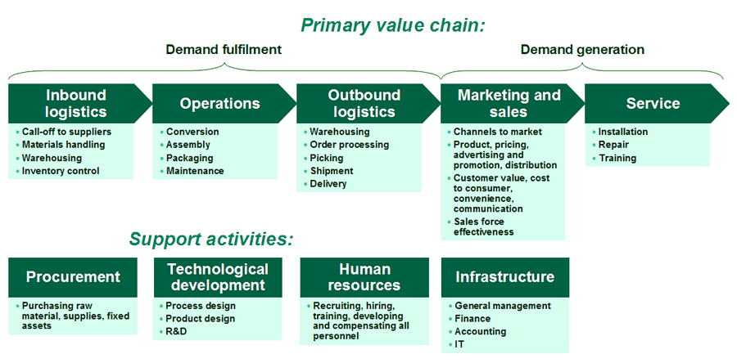
The main purpose for this is for Verizon to evaluate the competition, to determine what type of services and products the customers will need. This is helpful to determine the ways to make the company grow and remain successful. Verizon provides customers with wireless, residential, and business. Verizon operates the fastest 4G wireless network in America servicing more than 150 countries including all the Fortune 500 companies. Looking at the Porter’s model the purchasing and storing of materials in warehouse is the inbound, the assembling and manufacturing of product is the operations, gathering orders and packaging for distribution is the outbound, and ensuring that the products are on the shelves for customers purchases is the marketing and sales. Verizon strives for excellent service skills with a huge coverage including more towers than any other competitors that includes Sprint, AT&T and T-Mobile.
Current Competitive Position
With many changes in phones and accessories Verizon Wireless and AT&T dominate the market for wireless data and accounting more than two-thirds all US subscribers. Both providers hold the most licenses the FCC has issued for low-band wireless spectrum. With the wireless technology industries being heavily saturated market, Verizon has to be very completive to keep its customers.
Organizational Values
How Verizon differs from other telecommunication carriers?
Verizon Communications can be different in many ways, from different plans, phones, and prices. Competing with different communication company, Verizon communication has the nation largest coverage’s and the best plans. Verizon has the most licenses the FCC has issued for low-band wireless spectrum. A single tower low-band spectrum can cover three to three and half time than the high band transmitter in the geographic area. This means that Verizon can have more nationwide networks using fewer towers than other providers. Verizon’s is different from other providers by providing the ultra-fast FiOS wireless connection. Verizon is also different from other users because they have their fleet trucks being green and are being sustainable while not polluting or releasing emissions.
Partnerships
Partnerships for Verizon, includes many other organizations and programs, to achieve more mutual goals by creating diverse workplace. Verizon works with six different languages because many Verizon users are immigrants from different parts of the world and has expanded the language use of their systems. Verizon also partners with many other organization for events and charities to give back to the customers. Verizon’s companies that they partner up, Casa de Esperanza, Futures without Violence, and The US Environmental Protection Agency and many other agencies.
Verizon Communications have partnered up with a lot of major companies like Google and Comcast. Google has made agreement with Verizon communication in a commitment by the companies to devote substantial resources to accelerate delivery of leading-edge innovation that will put unique applications in the hands of consumers quickly. Verizon’s phone android is powered by Google which mean the phone is using Googles platform to operate the software and the phone. Verizon has also had bad experiences with companies that they have partnered up due to licenses and agreement issues. Verizon Communications has also partnered up with Comcast and they fell with the agreement because of antitrust laws and with Verizon and Comcast wanted to have a cable company spectrum that would boost the revenue services for both companies.
Wireless telecommunication is a great benefited industry in the U.S. A growing proportion of the population in the developed world, especially young tech-savvy consumers views cellphones as their sole phone and helped build $194.4 billion worth of revenue, and a $13.5 billion profit industry with 6.6% annual growth. Consumer expectations are high as most customers want their cellular telecommunications to provide cost-effective phone calls, SMS, MMS, email, web browsing and GPS, all backed by good customer service. More and more customers are disconnecting their landline phone services and are becoming wireless only households. As a result, revenue is expected to grow to $266.1 billion in 2018. Demand for this industry will only expand as this trend of consumers become more reliant on their cell phones.
Verizon Wireless has the largest market share with 41.8% of the industry followed by AT&T at 32.5%. Verizon’s 4G LTE network serves more than 273 million people, nearly 89.0% of the US population, as of January, 2013. This aggressive expansion strategy and early adoption of 3G and 4G infrastructure has helped Verizon to achieve an annualized revenue growth of 9.0%. However, over the next five years, Sprint and T-Mobile are expected to bolster their competitive positions against Verizon and AT&T through acquisitions and rapid expansion of their 4G-network coverage. It is important to plan ahead to stay in the game. Competition is based on the following basis:
Price
A major base of competition is pricing because product differentiation is often difficult. A key marketing promotion that continues to have an impact on the industry is the use of price caps. These price caps give users a high dollar value of calls for a set amount.
Verizon believes they never have and never will lead on price and are not convinced that the recent moves by the smaller carriers will engage in a price war.
On its unlimited plans, Verizon believes the rise of video and its affect on bandwidth will make it difficult for smaller carriers to maintain an unlimited plan because available spectrum needed to carry those signals are limited. It should be noted that the move to 5G wireless technology will be all about video.
Verizon suggests that it has network superiority over its rivals and that its LTE system is about a year ahead of its main rival AT&T. T-Mobile and Sprint are three to four years behind Verizon’s technology it believes.
Price comparison chart
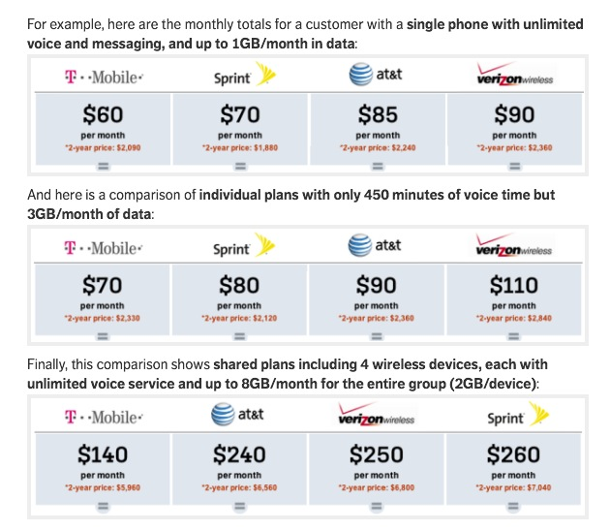
Service
Service is a very important competitive weapon because cell phone customers have placed greater emphasis on service reliability and problem resolution. Several, if not most cell phone carriers invested heavily in new technologies and upgrading their networks in an effort to establish different offerings on their quality of service and network coverage. This large range of services can provide competitive advantages in producing more for less as in economies of scale and scope.
Customer service is very important in achieving customer loyalty as in reducing customers who discontinue services and maintaining subscriber numbers.
American Customer Satisfaction Index, May 21, 2013
Verizon Wireless took first place in customer satisfaction among the Tier 1 wireless carriers, according to a survey conducted by the American Customer Satisfaction Index (ASCI). The ASCI measures how satisfied U.S. consumers are with the quality of products and services available to them. In this year’s independent study, Verizon Wireless scored above the industry average and placed higher than all other Tier 1 wireless carriers.

Product innovation
A critical competitive weapon within the cell phone industry is product innovation. This is due to the commercialization of new technologies which can be incredibly valuable in boosting use, bolstering margins and attracting new customers.
Bundling is also becoming a significant competitive point of product innovation. Competitors offer integrated combinations of the latest products and services to encourage customers to become multiproduct users. Verizon offers share everything plan.
How Share Everything Works
Share everything simplifies a plan by deciding how many devices one may want on their plan and add up the Monthly Line Access per device. Customers then complete their plan by selecting how much data they want to share across their devices, which is the Monthly Account Access.
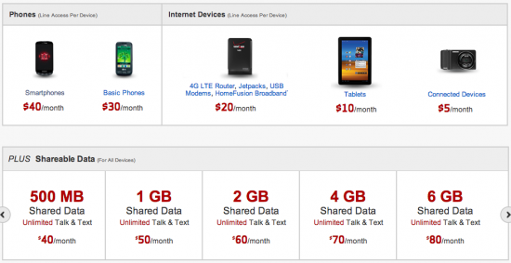
4G technology in the future will generate another wave of new value added products as the cloud impacts the social and business environment of the wireless phone industry.
Geographic coverage
Larger geographic coverage offers cost advantages and higher efficiencies as an additional competitive advantage.
The name of the company Verizon is a combination of the Latin word veritas (truth), and the English word horizon. It is a name created by blending two different words.
The name was chosen to label the company as both reliable and visionary.
4G LTE Coverage Map
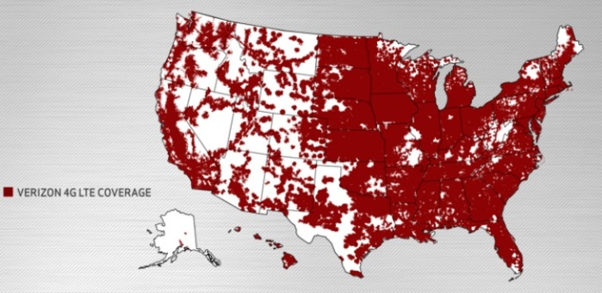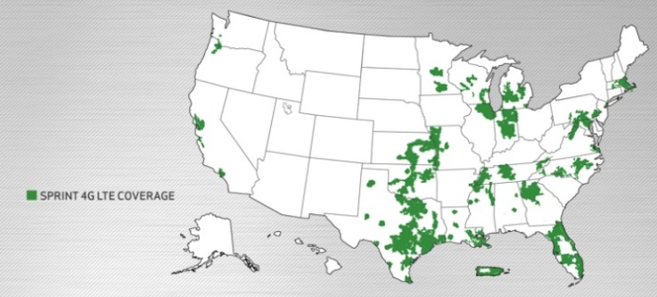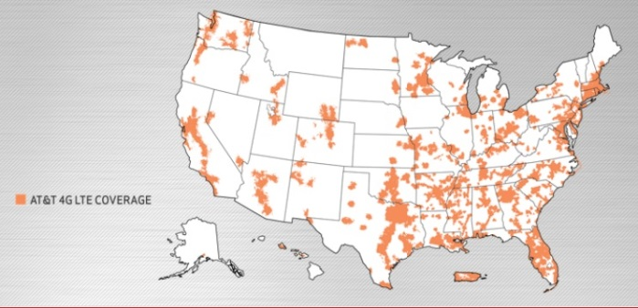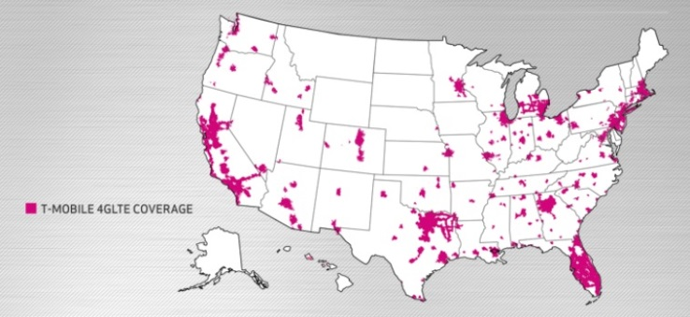
Key success factors
Developing close relationships in other industries
Developing strategic alliances with leading businesses is important for wireless carriers in supplier and buyer industries. Relationships on the supply side are critical to providing competitive service offerings and the best devices.
Verizon’s Innovation Centers inspire, enable, and showcase new innovations that tap the power of the Verizon Wireless 4G LTE network, the fastest, most advanced 4G network in America. Verizon is helping many companies develop breakthrough non-traditional devices, services, and applications that take full advantage of their 3G and 4G LTE networks. Together, they’re bringing amazing new products to the marketplace and changing the way we live, work, and play.
Enhancing Healthcare Delivery
Making Every Second Count With in Motion Technology and Verizon
CHALLENGE
In an emergency situation if the patient receives treatment within the first hour of an accident, their chances of survival improves dramatically. In meeting the challenge of enabling healthcare providers to evaluate patients more quickly, Verizon and In Motion are making significant contributions to the mobile healthcare area by improving communication between doctors, patients, and emergency response services.

ANSWER
Motion Technology in partnership with Verizon is delivering solutions to quickly monitor the location of emergency response vehicles, and dispatch the closest vehicle to the scene of an accident. EMS vehicles equipped with mobile routers function as mobile hotspots which allow these agencies to transmit vital patient data, over Verizon’s 4G LTE network, back to the hospital ER thus resulting in shorter response times and accelerated patient care.
IMPACT
Verizon’s 4G LTE network allows hospitals and first responders to quickly work with each other so that ER physicians are better prepared for patients before their arrival. This innovative wireless technology helps agencies improve on emergency vehicle response times. These advanced preparations and quicker dispatch of emergency vehicles will help to accelerate care and improve outcomes.
http://www22.verizon.com/powerfulanswers/solutions/healthcare/
Ability to quickly adopt new technology
Technological innovation is advancing at a rapid rate in the field of wireless telecommunications. This means technology life cycles are particularly short, making it essential for carriers to quickly embrace technological developments.
Verizon touted their network superiority over its rivals, noting that the LTE deployment is about a year ahead of its main rival AT&T, and three to four years ahead of its smaller competitors T-Mobile and Sprint.

Having completed its 4G LTE rollout this year, Verizon is starting to think about 5G technologies. Most notably to keep up with the demand from mobile video (Verizon CEO: Our Network's Way Ahead of AT&T, T-Mobile, Sprint) September 24, 2013 By Craig Galbraith.
http://www.billingworld.com/news/2013/09/verizon-ceo-our-network-s-way-ahead-of-at-t-t-mob.aspx)
Having a high profile in the market
Having name recognition is becoming increasingly important as the cell phone market nears saturation. Aspects that are key in a brand name include service reliability, network coverage and service pricing.
More customers recommend Verizon to friends and family over any other wireless network and more people stay with Verizon than any other wireless network.
Exclusive product sale contracts
Wireless carriers can gain a significant advantage with exclusive access to highly desired products, such as with Apple’s iPhone.
Verizon customers finally gained access to Apple’s iPhone, in early 2011, stimulating growth for the network and causing a 10.5% increase in revenue.
Economies of scale
“Wireless participants are focusing their activity of retaining and building their subscriber base. A larger subscriber base enables more spreading of fixed network costs, which improves profitability.”
Verizon’s 4G LTE network covers more than 273 million people, nearly 89.0% of the US population, as of January 2013. This vast network footprint and subscriber base allows the firm to spread its network fixed costs over more customers, lowering operating expenses and boosting profit margin.
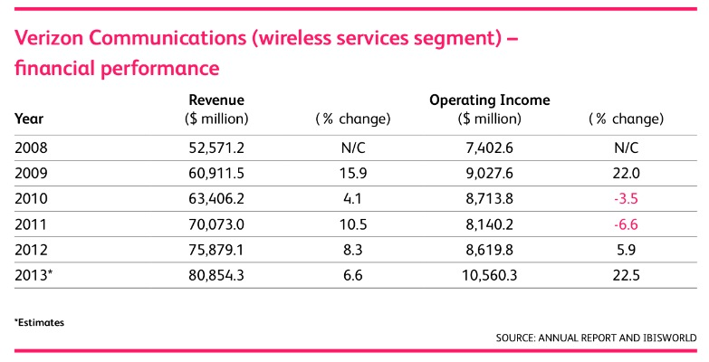

How Loyal Are Your Customers to a certain product?
“Standing out in a world of choice isn’t easy. Earning consumer devotion to a brand or store takes more than just offering a good product. Price, packaging, customer service and reputation are just some of the factors involved in a consumer’s decision-making process. That’s why getting to the heart of what makes a consumer stick or switch can be the difference between flourishing and fading. While Nielsen research shows that bigger rewards generally inspire higher loyalty levels, loyalty programs are no guarantee of loyal behaviors. “
Global | 11.12.2013
How do you turn an unsure customer into a faithful follower? You start by understanding the needs and motivations that drive their purchase decisions. And then you incorporate strategies and tactics that deliver the most value. The following Nielsen global survey gives us an insight into what drives consumers to switch brands, service providers or retailers and identifies the loyalty program qualities that potentially have the most staying power.

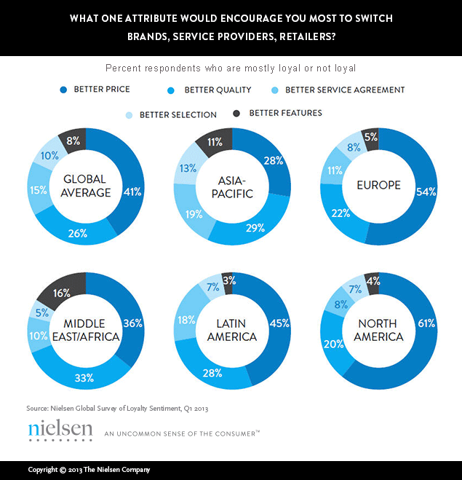

Verizon’s market is shared by many such as Sprint, AT&T, and T-Mobile to just name a few. This makes for intense competition. All these companies provide the same service. Sprint uses its “Dare to compare” campaign so that consumers can compare Sprints prices to Verizon and AT&T. They also have improved their network to have a faster data speed and a stronger indoor signal. Sprint is known to be environmental. They are ranked #3 among 500 U.S. Companies. Sprint does a buyback plan for old cell phones and uses reusable envelopes to save electricity. AT&T has the 4G LTE broadband. AT&T has started a plan that consumers can update their phone every year instead of every 2 yrs. with no fees, a trade in for old phones from any company and get a promotion card, and they also give discounts from certain schools, employers, or military service. They pride themselves on their customer service and offer rollover minutes. They received J.D. power top wireless purchase experience. AT&T have introduces U-Verse TV plan with high speed internet, and phone bundle. T-Mobile is a smaller company but is growing with popularity because they offer low or no fees and they now have gone global in over 100 countries. They also have 4G LTE but they have no credit check plans, customers can upgrade at any time and they offer free shipping for all devices. T-Mobile will also take any device from another company and switch them over, no other company does that. Smaller companies are everywhere that offer no contract phone plans with all the same amenities that these bigger companies offer but at a lower price. They also provide unlimited data plans for worldwide use.
The technology in the telecommunications market is ever changing and in new directions. A new dual-screen cell phone will launch in December. The new Russian brand phone has a LCD screen on the front and the new e-ink display on the back. Technology is becoming a younger and younger trend. The heaviest users are teens and consumers in their early 20’s. This target market sets the trends and direction that innovators and inventors are designing for. Social media is a huge trend today along with e-books, and I-tunes. Games such as Candy Crush have changed the way we look at the phone. Cell phones are no longer just a device to call and communicate on now they are used for entertainment. TV and movies can also be watched on a cell phone. There for, Verizon’s target market has shifted as well. Younger consumers want faster and cheaper products that can accommodate all of these things and more. The more features and the more applications that products can have is in high demand. Consumers are looking for products that have a multi-level purpose and can be used in conjuncture with other electronics.
The economy is in a slow period. The cell phone market is the slowest it has been since 2009. When the economy is slow spending is decreased. Consumers tend to save when the economy is not doing so well. Shipments of cell phones have been predicted to increase to 4%. Sales will drop by 10% from 1.8 compared to 2011 1.7 billion. The Iphone’s market share have also dropped from 20.5% to 19%.
Not only does the economy have an affect but government regulations can make or break Verizon’s plans for expansion. The FCC has in place rules for an open internet called net Naturalization. These rule govern broadband to allow all internet through there devices with no blocking. Broadband is also to disclose their policies. Verizon fights now to lobby the Canadian government on their section 7 Telecommunications Act. This policy is stopping or changing the growth of Verizon in Canada.
Verizon has and will continue to promote and encourage innovation inside and outside the company walls. Verizon has set up a program to pay these innovators for their ideas to get that jump on something new and stay ahead of the game with all the dozens of other telecommunications companies out there. Verizon pushes their employees to think outside the box. Verizon is not threatened by people outside the company that have great new ideas. The innovation program welcomes these people in and helps their ideas come to life. The target market has shifted to a younger audience. Therefore marketing and creating products that appeal to a younger crowd is the direction that Verizon needs to continue to go. Teens like bright, fun, and new ways to use their tablets and phones. Joint venturing with another company is a great way to introduce change and increase market share for Verizon and the joining company. AT&T did it with Apple to create new products and a new market. Video-conferencing is expanding and there is a great want for greater access. Bundling and offering a discount on the overall plans is a great way for consumers to utilize the other features of the company and not go to the competitors for another service that Verizon already provides. Verizon is a global company but there are still areas that can be saturated and expanding the broadband 4G into all areas is a work in progress.

