2017
Jose Villarreal, Francisco Silva, Yvonne Valdes
New Mexico Highlands University
Strategic Management 489 - Fall
GoPro Professional Sports Campaign
New Mexico Highlands University
Strategic Management 489
To: Dr. Ortiz
From: Jose Villarreal, Francisco Silva, Yvonne Valdes

Introduction:
GoPro has revolutionized the way we record our lives. The photos and videos on their YouTube, Facebook, Twitter, Instagram and Pinterest accounts are relevant, including a video of the day, and the way they market is with flash to a younger demographic. The uniqueness behind their marketing strategy gains one's imagination and takes it to a whole new level. The videos that are submitted and archived are from around the world which broadens a perspective that other competitors do not match. GoPro campaigns are ridiculous in promoting each new camera with strategic co-brand alliances like red bull; another extreme sports brand targeting the same demographic.
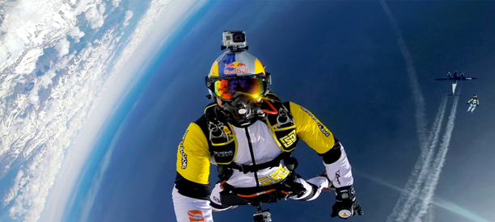
Mission Statement:
The GoPro mission is to help people capture and share their lives most meaningful experiences alone and with others; and to celebrate them together. In modern days you're supposed to show things like a day with family up in the mountains. With GoPro cameras it’s more meaningful when you spend the day in the mountains alone; capturing the moment. It’s sharing our collective experiences in the moment. The best way to share that and capture it is with GoPro because they make the most versatile cameras. “Enabling you to share your life through incredible photos and videos by capturing, creating and sharing the world's most GoPro perspective with versatile cameras” - Nicholas Woodman GoPro CEO and founder.
Vision Statement:
Woodman’s GoPro is much more than just a device you can record with because it's something that will document all your life experiences. It gives you the ability to share and communicate with everyone online and show your adventures. Woodman describes the entrepreneurial journey as “entering a dark forest filled with scary things, plowing through and eventually coming out on the other side to the cheers of friends because you’re achieving your goals”. Some visuals can be to embrace your dreams because that is what's going to give you your fuel for all your passion. Be relevant to your time and catch everything as a video; you can reflect and remember the journey. Be authentic: do all your creative ideas your own way without someone telling you how to do them. GoPro isn't just another company where you take pictures and videos but they want their product to be a part of your life and your everyday activities.
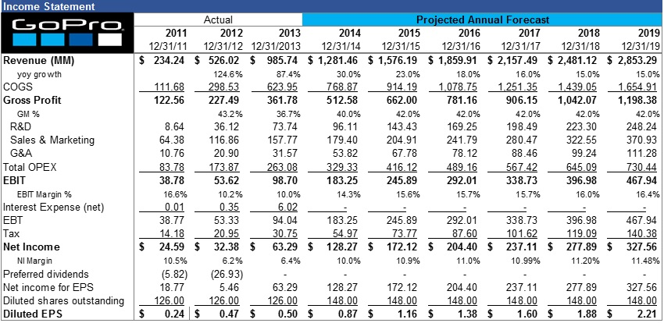
Competition:
The GoPro Hero5 Black is currently ranked #1 among its competitors which include, #2 TomTom Bandit, #3 Drift Ghost HD, #4 YI 4K Action Camera and #5 Olfi one.five, according to techradar.com. Sony FDR-X3000R ranks #6 and that is the only competitor that is recognizable in GoPro’s market.
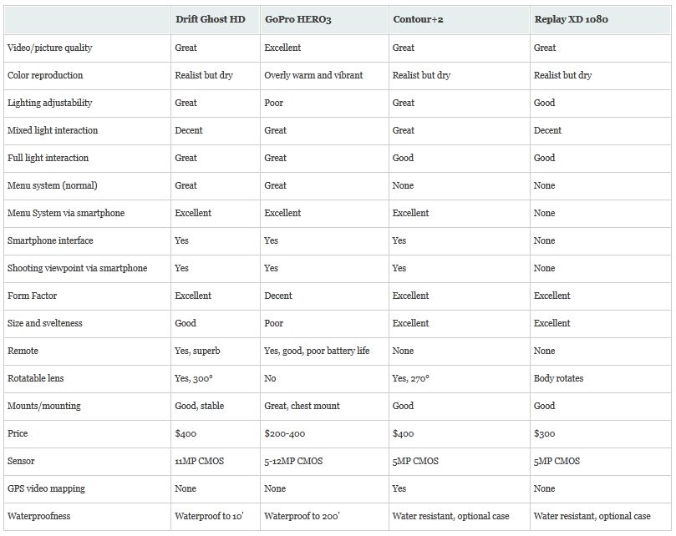
The Drift Ghost HD action cam website for comparison have nice action photography and an immediate go to purchase point similar to GoPro’s website. The Drift Camera website has a grand total of 1 decent video with some content that connects their following on social media. GoPro’s videos on their website are innumerably awesome, adventurous, unimaginable and incredibly stable. The Drift Ghost is competitive in their price range, but would rather buy something that costs a little more, that is higher in quality and is going to give a sense of durability.
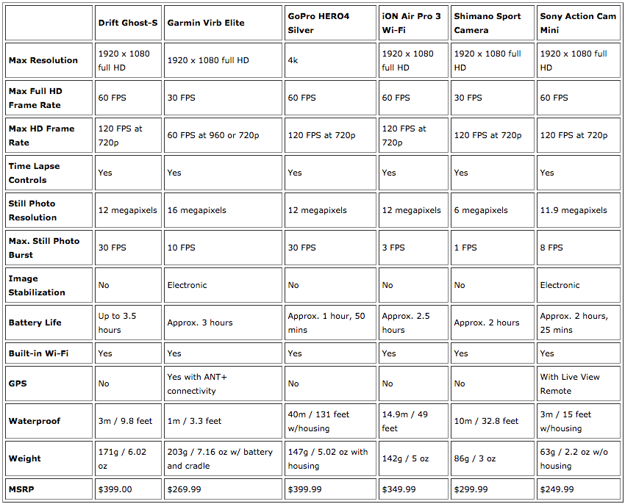
The way GoPro markets their product gives the sense that they are a quality business and sell a product that is worthy and valuable. This is not the same for the The Drift Ghost and other competitors of GoPro. The Drift Ghost has links to Facebook, Twitter, YouTube, Instagram and LinkedIn, but their Instagram page; which is their first link to click on, views as elementary level compared to GoPro’s graduate level. The content on The Drifts Instagram account are all “still” photos, whereas GoPro has unlimited videos on their website and social media links as well.
Ultimately, GoPro has heaps of credibility and longevity in their product and has a larger following on each of their social media sites; 1 video on YouTube alone has nearly 45 million views. They have and continue to master the product they sell, and give the consumer peace of mind knowing that they are going to get their money’s worth. They make you want to go extreme and motivate you to go beyond your limitations. GoPro is the revolution in action camera technology, and their marketing video strategies are epic.
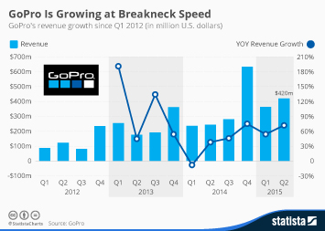
Strategic Business Plan:
We as strategic managers and entrepreneurs would like to initiate the promotion of GoPro cameras in the Professional Sports platform. Our campaign will have GoPro and Sports organizations meet our proposition in our creative business strategy: GoPro cameras will be given to all referees and front-row seated fans in all Professional Sports live games in the creation of a new way to view the game on an extreme level. The contractual agreements between GoPro and Sports organizations, including live television broadcast and internet live-stream video companies, will allow live feeds available for all fans around the world on all professional sporting events. This will enable live-stream viewing fans an inside look into dugouts and on-field play; an “in the huddle” type atmosphere where any normal citizen would not be able to see on a regular television broadcast.
Our goal will be: to have GoPro obtain contractual agreements and sponsorships with major television broadcast companies and also live-stream broadcast companies, like YouTube, in order to allow them (GoPro) to accommodate free cameras to the appropriate fan base; for example front-row seating, as well as the referees in order to give these unique viewing experiences. GoPro can change the way the television audience views sports from this point in history while carving out their own history. Just like GoPro has revolutionized the way we view our normal everyday lives; this campaign will change the way live sports television is viewed.
Abstract Ladder to Success:
The initial step in this process will be to add cameras to referees. This real life virtual feeling will give fans a better feel for what is being produced on the field. It will be like they are literally on the field with the players. This is the revolution we expect for GoPro, and since GoPro will be the market holder in this endeavor, we expect a multi-year, multi-million dollar or euro contract with all major live television broadcast companies.
The next step in our campaign will be to give GoPro cameras to all front-row ticket holders for all major sporting events. This strategy will give incentive to fans to purchase these seats and will ultimately increase team and industry revenue on an extreme magnitude.
In the final step: GoPro, in conjunction with contractual television broadcast companies and live-stream companies, will offer a free trial to online viewing consumers to view the content of these events through the lens of GoPro cameras. Once the trial ends, the consumer will be given the option to continue watching the content as a monthly subscriber.
Conclusion:
In conclusion, the revolution of real-life action videos from GoPro cameras have given us the entrepreneur and strategic manager an idea to revolutionize the way we view our favorite sports teams in live feeds that were never sought possible. GoPro has proven its worth in the market share it competes in versus action camera competitors; therefore we can strategically hold them on a different level of sustainability and reliability. We expect their company to continue to innovate and we will follow their trend as we elevate and leverage their product with our proposition in the market of Professional Sports.
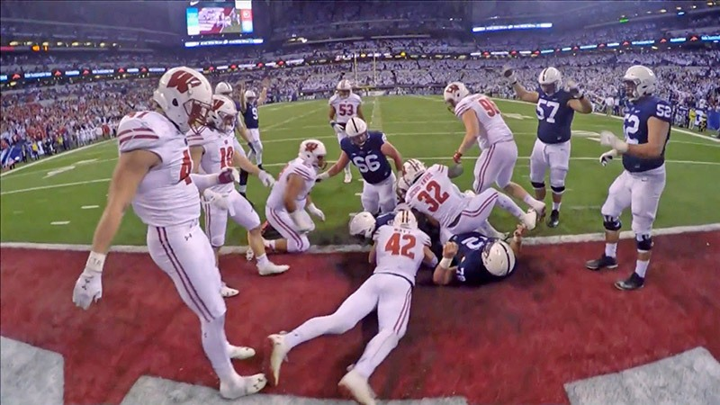

Works Cited:
- GoPro, Inc. Copyright 2017. All Rights Reserved. https://gopro.com/.
- https://www.instagram.com/GoPro/
- https://twitter.com/gopro
- https://www.facebook.com/gopro
- https://www.youtube.com/user/GoProCamera
- Woodman, Nicholas. GoPro Be a Hero. Code of Business Conduct and Ethics. The GoPro Code of Honor. http://corpdocs.msci.com/ethics/eth_318018.pdf
- LinkedIn Corporation. Copyright 2017. SlideShare. The Mission, Vision, Values and Strategic capabilities of GoPro. https://www.slideshare.net/antreasch/the-mission-vision-values-and-strategic-capabilities-of-gopro
- Drift Innovation. Copyright 2017 Drift. E-Commerce by WEMAKEWEBSITES. https://driftinnovation.com/
- Big Ten Network. Nov 28, 2016. Go on the Field During Wisconsin-Minnesota. https://www.youtube.com/watch?v=OzX2Y8aMvDE
- GoPro. Dec 25, 2015. GoPro: Best of 2015 – The Year in Review. https://www.youtube.com/watch?v=IyTv_SR2uUo
- GoPro. Dec 23, 2016. GoPro: Best of 2016 – A Year in Review. https://www.youtube.com/watch?v=Jc8VaMQ5aOo&t=

