Grupo Bimbo SA
Strategic Plan

Miriam N. Flores
Strategic Management 489
Dr. Luis Ortiz
March 17, 2017
Table of Contents
Introduction / Company History 3
Mission and Vision 4
Corporate Culture 4
Evaluate Market Segment 5
Develop Target Profile 6
SWOT Analysis 7
Strategic Plan Roll Out – SWOT Findings 8

History
Grupo Bimbo SA is a bread manufacturer originally named Panificación Bimbo in 1945 starting with only 34 employees. It has since expanded from being a small somewhat family run bakery of loaf bread in Mexico City to a conglomerate business growing so much to having 163 manufacturing plants in over 22 countries, spanning over three continents. It originally began with only four basic products, cellophane wrapped large and small white loafs of bread, rye bread and toasted bread. With its 130,000 employees worldwide today Bimbo is able to offer over 10,000 products under its 100 different brands (IBISWorld, n.d.). Grupo Bimbo USA has 60 bakeries, employs 22,000 associates and has 11,000 routes in the USA alone. Grupo Bimbo SA has strategically placed themselves at the top of the baker food chain by always trying new things and keeping with their core values. As Grupo Bimbo SA has evolved so have their Mission and Vision statements throughout their brands. Grupo Bimbo prides themselves in being socially responsible and treating their employees well.
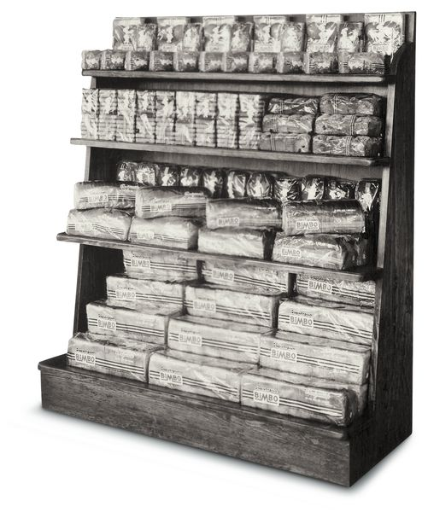

Mission
Delicious and nutritious baked goods and snacks in the hands of all. To nourish, delight and serve our world.
Vision
To be the best baking company in the world and leader in the food industry, where our people make the difference every day. In 2020 we transform the baking industry and expand our global leadership to better serve more consumers.
Corporate Culture
At Grupo Bimbo they basically believe that you are only as strong as your weakest link. They have a saying almost since their foundation, “A Company is what their associates are, and the associates are what their leaders are.” (Grupo Bimbo Website, n.d.) They believe in growing their employees and allowing them to develop their skills bringing out the best in each of them. They value their employees and care for their health, safety and wellbeing offering competitive pay and opportunities while maintaining a good relationship with the unions where they are in place. They keep the distribution drivers safe by keeping the vehicles well maintained and run under the slogan “safety, skills and courtesy” (Grupo Bimbo Website, n.d.). They strive to offer an extraordinary place to work by providing a safe work environment, open door policy, and opportunities for training and growth within the corporation.
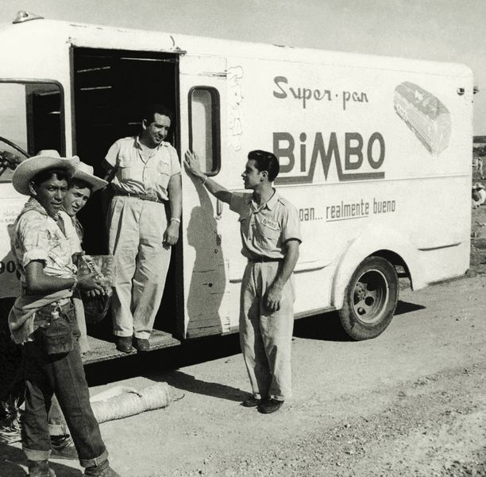
Social responsibility is also a goal of Grupo Bimbo. They are continuously working on R&D to lower their carbon footprint and be ahead of the rest. Their newer vehicles are fuel efficient, low energy consumption and control CO2 emissions. Their strategic planning integrates sustainability, with this in mind, they created the Institute for Innovation and Nutrition (Institutos de Innovación y Nutrición). Here they offer educational programs on health, nutrition and sustainability. This is where there innovations come together and bring life to new products offering more nutritional products of high quality (Grupo Bimbo Website, n.d.).
Evaluate Market Segment
With the wide variety of products it produces, Bimbo is able to reach the vast majority of the population. The Bimbo brand has typically dedicated itself to the basic household items like loaf bread, hamburger and hot dog buns, Pan Dulce (sweet breads), and their famous pan tostado (toast), they are almost all made with white flour. The staples in most homes are enjoyed by the entire family therefore giving them the advantage of reaching more consumers. Other brands that have joined Grupo Bimbo are Boboli and Tia Rosa. Boboli is a pizza crust producer. These crusts not only serve for pizza but people also enjoy them in dessert recipes and enjoy their versatility of uses (Boboli Web site, 2017). Tia Rosa started in Mexico as a producer of Pan Dulce and pastries and has since become the #1 flour tortilla brand in Mexico (Tia Rosa Web Site, n.d.). With the ever changing market and consumer demand Grupo Bimbo has embraced change to their benefit and made some revenue generating acquisitions of other brands like Oroweat and Earth Grains to reach the health conscious groups.
Develop Target Segment Profile
Grupo Bimbo is a leader in innovation. As more people take time to research and make themselves aware of their family’s health and wellbeing, so does Grupo Bimbo. They were the first to make the Bagel Thins® Bagel by the THOMAS brand, catering to the low carb consumer and having only 110 calories. Today there is a lot of buzz about cutting carbs and also gluten from our diets due to the growing rate of obesity and other health reasons not related to weight, Grupo Bimbo listens and is targeting this segment in the industry. The acquisition of the Eureka brand offers USDA organic, certified vegan products. Eureka has even innovated their bread packaging by using renewable and sustainable technology. (eurekabread Web site, n.d.) They have also offer a gluten free option through their Goodbye Gluten brand. Many consumers have found that their bodies do not react well to gluten, something many flour based products have. Goodbye Gluten offers various products for all to enjoy like white and wheat bread and wraps (goodbye gluten bakeries, 2017). The fact that Grupo Bimbo has taken the time to develop new products either by their own innovation or the acquisition of brands like Eureka and Goodbye Gluten bakeries gives them the opportunity to reach new consumers or have their already loyal consumers stay if they had been in the hunt for healthier choices. These products are more expensive to produce but also sale for a higher margin therefor giving the company a greater return.
SWOT Analysis
Strengths | Weaknesses
- Customer Loyalty  - Long history in the industry  - Quality service  - Social Service  - Strong commitment to excellent service  - Leading innovators  - Location - Mexico | - Potential conflicts of interest  - Key stakeholder conflicts of interest  - Originating Corp headquarter location. Mexican laws; government control over economy
Opportunities | Threats
- Move into other continents  - Better contract negotiations  - Acquire non bread companies  - Expand marketing opportunities | - Strong competitors  - Making a change too soon  - Contract changes upon renewal  - Loss of key employees  - Anti-monopoly law limiting further acquisitions

Strategic Plan Roll Out – SWOT Findings
Threats - Grupo Bimbo SA currently has a 9% market share in the fresh bread and bakery goods wholesaling segment per IBISWorld (IBISWorld, n.d.). Although they have shown great strides through their acquisitions and innovation, they still face threats. Flowers Foods Inc. is the second leader in this segment with a 5.3% market share. Grupo Bimbo has to be in tune to what the suppliers are offering them versus the competition. Maintaining good relationships is key to getting the best contracts negotiations outcomes. The next threat to Grupo Bimbo is SYSCO Corporation with a 4.9% market share. Although SYSCO does not do as much internal production as Grupo Bimbo, they are mostly distributors, they still may have the capital to purchase a large bakery that does have this capability. They are great innovators but rolling out a product too soon may also cause them to lose financially if the consumer does not jump on the wagon and the demand is too low, this will have them to lose and have waste going against their social responsibility values.
Weaknesses - The location where this corporation first started is both a weakness and a strength. Located in Mexico City there is little a consumer or competitor can due to bring legal action against a shareholder or the company itself. The Mexican government has the control over the economy and this is also why their location may be a weakness. Key stakeholders belong to various committees and form part of other boards of directors, this may also be a conflict of interest if this takes too much time away from the Grupo Bimbo Corporation and their interests.
Strengths and Opportunities – Being the first to have a collective bargaining contract signed together with the Flour, Bread and Confectionary Union in Mexico City gives them leverage to manage future contracts. They were the first to pave the way in the industry and have the upper hand. Their long history in the industry has allowed Grupo Bimbo SA to gain a strong consumer loyalty. This is key for a company as large as this. Customer loyalty will allow Grupo Bimbo venture out into different market segments and introduce new products, all they would need to see is the famous little white bear associated with the new product. One opportunity that they have is to purchase a company other than a bakery. For example, if they purchased a pasta sauce company they would be able to have this combine with their Boboli pizza crusts. This would bring their brands full circle and a company could have a full meal with products all under the Grupo Bimbo umbrella. Their commitment to their employees and the consumer in having quality service and products is what sets them apart from the rest. Grupo Bimbo SA has demonstrated throughout the years that is has been able to strategize to not only grow in its originating country but has been able to grow its market share globally.

References
(n.d.). Retrieved from Tia Rosa Web Site: http://www.tiarosa.com/about-us/our-family.php
(n.d.). Retrieved from eurekabread Web site: http://eurekabread.com/about
(n.d.). Retrieved from Grupo Bimbo Website: http://www.grupobimbo.com/informe/en/about/our-history.html
(n.d.). Retrieved from Grupo Bimbo Website: http://www.grupobimbo.com/es/innovacion/institutos.html
(2017). Retrieved from Boboli Web site: http://www.boboli.com/BoboliHistory.aspx
(2017). Retrieved from goodbye gluten bakeries: http://goodbyeglutenbakeries.com/products.php
IBISWorld. (n.d.). Retrieved from IBISWorld: http://clients1.ibisworld.com/reports/us/industry/print/majorcompanies.aspx?indid=5876

